**Summary**

Telliscope makes it easier for Africa-focused companies, policy makers and investors make informed investment descions by providing actionable and relevant insight. Telliscope is based Washington DC and Addis Ababa, Ethiopia and currently works with 10 public insitutions in Ethiopia to support the busisnes and policy community.

*Sample Data Briefs*

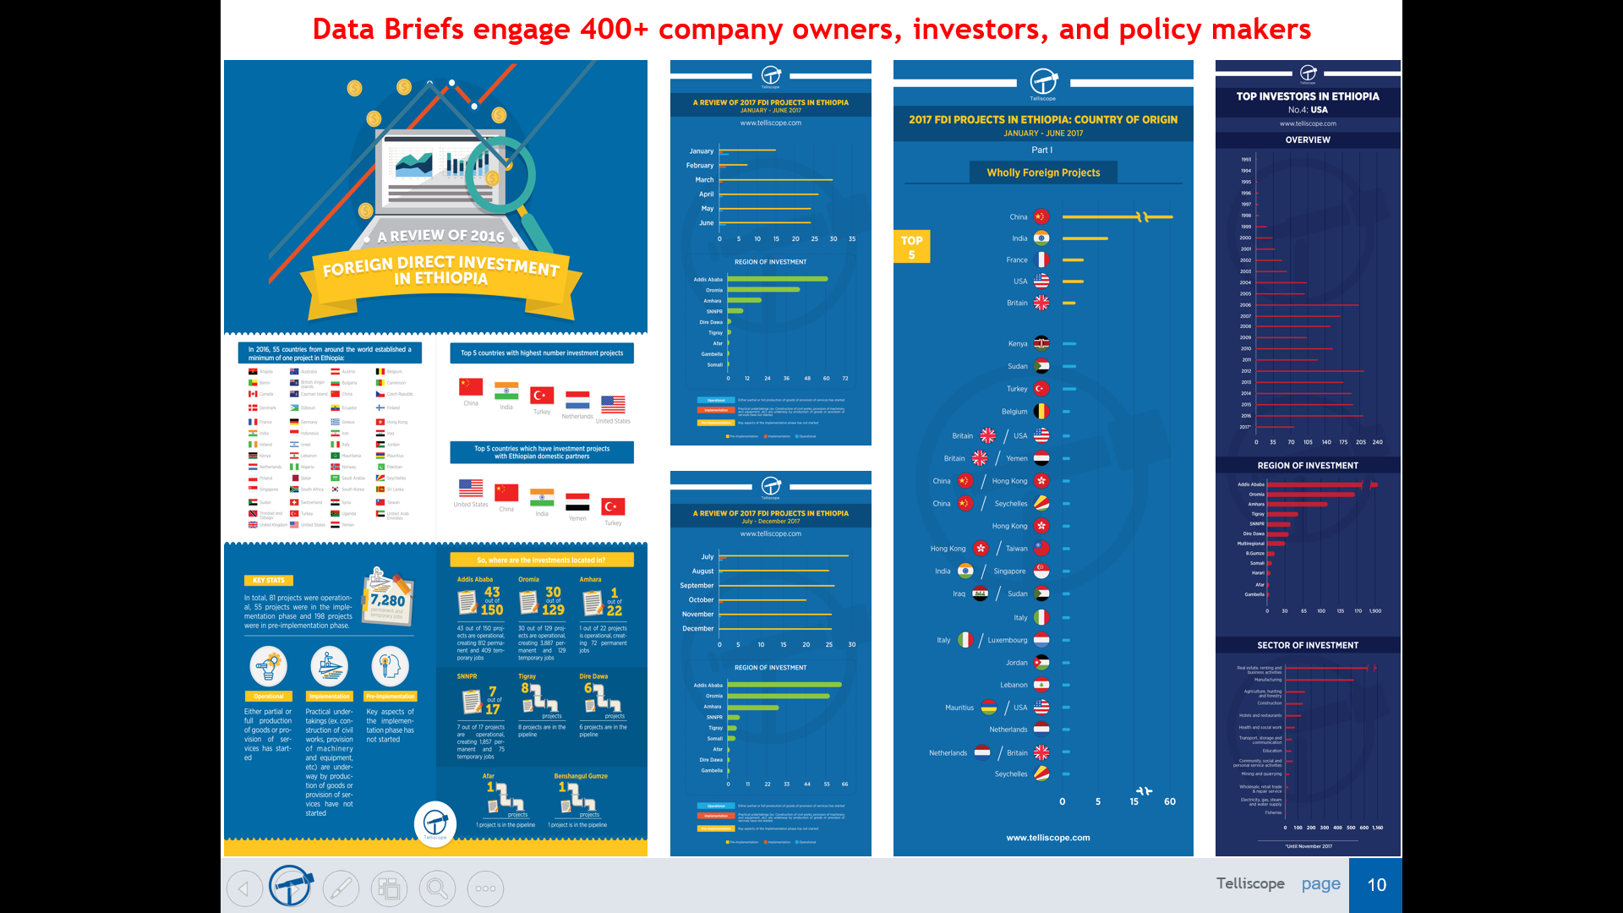

Research Framework

**Background: Ethiopia’s Growth and Transformation Plan II (2016-2020)**

The first Growth and Transformation Plan (GTPI) culminated with registering remarkable achievements in real GDP growth, infrastructure development, social development and capacity building at all levels. During the implementation period of GTP I, public participation and common development spirit and sense of ownership has been stimulated on key national development issues. The achievements of the development Plan at all levels through community mobilization have set the foundation for economic transformation and the country’s Renaissance journey. To this end, during GTP I implementation period, significant achievements have been registered in domestic saving & investment. However, the gap between domestic saving and investment has been widening in the country during GTP I implementation period. Similarly, the gap between merchandize export earnings and merchandize import bill, the trade deficit, has been widening during GTPI implementation period. The share of merchandise imports bill financed by merchandize export earnings has been declining over the GTPI implementation period. Notwithstanding the encouraging achievements registered in the manufacturing sub- sector, performance has still fallen short of the targets set in the Plan. Despite the promising results witnessed in good governance, public satisfaction has not been realized as desired.

**Overview for DataKind DC - Telliscope**

1. **Setting the stage: Insights from existing 5 imp/exp data and 10-year investment activity data**
2. **Import Substitution: Impact of Investments on Imports/Exports**

General

1. What are the overall trends of import and exports over the past 5 years?
   1. Seasonality/cycles in imports and/or export activity?
      1. Which imports have increased over time?
      2. Which export have decreased over time?
   2. Has the devaluation of the birr to USD affected imports and/or exports over the past 5 years?
      1. Link for USD – ETB currency exchange historical: <https://www.xe.com/currencycharts/?from=USD&to=ETB&view=10Y>

Imports

1. What are the trends of the top 20 imported commodities?
   1. Amount, volume
   2. Taxes paid
   3. Where are most of commodities sourced from?
      1. What commodities are sourced from the Top 20 Import countries?

Exports

1. What are the trends of the top 20 export commodities?
   1. Amount, frequency
   2. Where are most of commodities sent?
      1. What commodities are sourced from the Top 20 Import countries?

Investments (General)

1. Trend of investment activity over 10 years
   1. Location
   2. By industry

Investment and Import Substitutions

1. FDI activity impacted the commodities that are imported and/or exported (ex. Has FDI activity decreased commodities that are usually imported into the country?